Classification Report Explanation

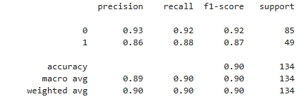

1. Precision:
- Measures how many predicted positives are actually correct
- Formula:
Precision = TP / (TP + FP)
- 0 0.93
- 1 0.86

2. Recall:
- Measures how many actual positives were correctly identified
- Formula:
Recall = TP / (TP + FN)
- 0 0.92
- 1 0.88

3. F1-Score:
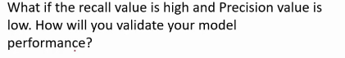

- Harmonic mean of precision and recall
- Best metric when data is imbalanced
- Formula:
F1 = 2 × (Precision × Recall) / (Precision + Recall)
- 0 0.92
- 1 0.87

4. Support:
- Number of actual samples for each class in the test dataset
- 0 85
- 1 49

Class True:
- Precision: 0.93
93% of samples predicted as class 0 are correct
- Recall: 0.92
92% of actual class 0 samples are correctly identified
- F1-Score: 0.92
Strong balance between precision and recall
- Support: 85
85 actual samples belong to class 0

Class True:
- Precision: 0.86
86% of predictions for class 1 are correct
- Recall: 0.88
88% of actual class 1 samples are correctly identified
- F1-Score: 0.87
Slightly lower than class 0 but still strong
- Support: 49
49 actual samples belong to class 1

Accuracy: 0.90:
- The model correctly classifies 90% of all samples
- Accuracy alone is not sufficient for imbalanced datasets, so other metrics are important

Macro Average:
- Precision: 0.89
- Recall: 0.90
- F1-Score: 0.90
- Treats both classes equally, regardless of sample size

Weighted Average:
- Precision: 0.90
- Recall: 0.90
- F1-Score: 0.90
- Takes class imbalance into account (more weight to class 0)

